**Write a Java Program to Demonstrate a Basic Calculator using Applet**

**Package java** ;

**Import** java.awt.*;

**Import** java.applet.*;

**Import** java.awt.event.*;

**Public class**Calculator **extends** Applet **implements** ActionListener

{

TextFieldinp;

//Function to add features to the frame

**publicvoid**init()

{

setBackground(Color.***white***);

setLayout(**null**);

**int**i;

inp = **new**TextField();

inp.setBounds(150,100,270,50);

**this**.add(inp);

Button button[] = **new** Button[10];

**for**(i=0;i<10;i++)

{

button[i] = **new** Button(String.*valueOf*(9-i));

button[i].setBounds(150+((i%3)*50),150+((i/3)*50),50,50);

**this**.add(button[i]);

button[i].addActionListener(**this**);

}

Button dec=**new** Button(".");

dec.setBounds(200,300,50,50);

**this**.add(dec);

dec.addActionListener(**this**);

Button clr=**new** Button("C");

clr.setBounds(250,300,50,50);

**this**.add(clr);

clr.addActionListener(**this**);

Button operator[] = **new** Button[5];

operator[0]=**new** Button("/");

operator[1]=**new** Button("*");

operator[2]=**new** Button("-");

operator[3]=**new** Button("+");

operator[4]=**new** Button("=");

**for**(i=0;i<4;i++)

{

operator[i].setBounds(300,150+(i*50),50,50);

**this**.add(operator[i]);

operator[i].addActionListener(**this**);

}

operator[4].setBounds(350,300,70,50);

**this**.add(operator[4]);

operator[4].addActionListener(**this**);

}

String num1="";

String op="";

String num2="";

//Function to calculate the expression

**publicvoid**actionPerformed(ActionEvente)

{

String button = e.getActionCommand();

**char**ch = button.charAt(0);

**if**(ch>='0'&&ch<='9'|| ch=='.')

{

**if** (!op.equals(""))

num2 = num2 + button;

**else**

num1 = num1 + button;

inp.setText(num1+op+num2);

}

**elseif**(ch=='C')

{

num1 = op = num2 = "";

inp.setText("");

}

**elseif** (ch =='=')

{

**if**(!num1.equals("") && !num2.equals(""))

{

**double**temp;

**double**n1=Double.*parseDouble*(num1);

**double**n2=Double.*parseDouble*(num2);

**if**(n2==0 &&op.equals("/"))

{

inp.setText(num1+op+num2+" = Zero Division Error");

num1 = op = num2 = "";

}

**else**

{

**if** (op.equals("+"))

temp = n1 + n2;

**elseif** (op.equals("-"))

temp = n1 - n2;

**elseif** (op.equals("/"))

temp = n1/n2;

**else**

temp = n1*n2;

inp.setText(num1+op+num2+" = "+temp);

num1 = Double.*toString*(temp);

op = num2 = "";

}

}

**else**

{

num1 = op = num2 = "";

inp.setText("");

}

}

**else**

{

**if** (op.equals("") || num2.equals(""))

op = button;

**else**

{

**double**temp;

**double**n1=Double.*parseDouble*(num1);

**double**n2=Double.*parseDouble*(num2);

**if**(n2==0 &&op.equals("/"))

{

inp.setText(num1+op+num2+" = Zero Division Error");

num1 = op = num2 = "";

}

**else**

{

**if** (op.equals("+"))

temp = n1 + n2;

**elseif** (op.equals("-"))

temp = n1 - n2;

**elseif** (op.equals("/"))

temp = n1/n2;

**else**

temp = n1*n2;

num1 = Double.*toString*(temp);

op = button;

num2 = "";

}

}

inp.setText(num1+op+num2);

}

}

}

/*

<applet code = Calculator.class width=600 height=600>

</applet>

*/

**OUTPUT**

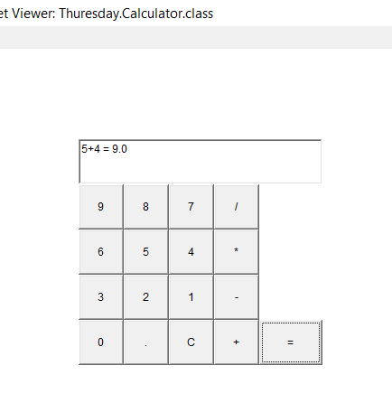 **ADDITION SUBSTRACTION**

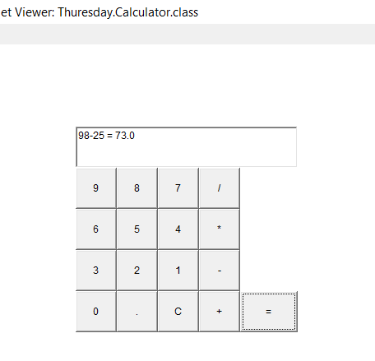

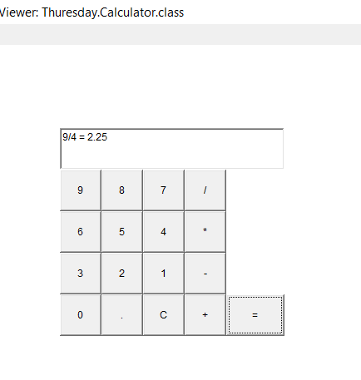 **MULTIPLICATION DIVISION**

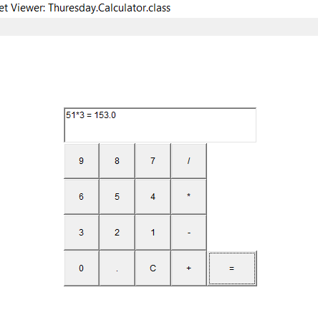

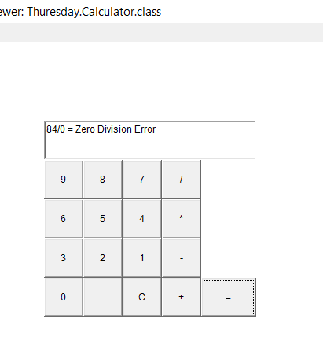**DIVISION BY ZERO ERROR**